DESIGN AND DEVELOPMENT OF SOFTWARE FOR DISEASE DETECTION AND MANAGEMENT OF LEAFY VEGETABLES

**Abstract**

This paper presents a web-based software for disease detection and management of leafy vegetables.

In India, a wide range of leafy vegetables are consumed. Our software presents the solution to the most normal problem encountered in the leafy vegetables i.e. diseases. This software is developed to help the farmers to easily detect the diseases of leafy vegetables by using image processing technique. Diseases can be identified by either using colored images of the infected vegetable or the textual information. After the disease is idenetified, proper management of the disease is provided.

**Keywords** : Web-based software, disease, management, pixel comparison.

1. **Introduction**

Agriculture zone serves the food desires of the human race. It has played a key responsibility in the development of human civilization. Research in agriculture is designed to increase the efficiency and quality of agricultural product. In agriculture, applications of computer system are mainly found in the area of diseases diagnosis. Disease’s detection application is implemented to upgrade the agricultural sector. Disease management makes available accurate treatment advices. Leafy vegetable crops are susceptible to a wide variety of diseases that can severely reduce yield and quality. Diseases can occur in the field or in storage and are caused by infectious bacteria, fungi, viruses and other related organisms. The main reason for the development of this system is to enable a layman to easily detect and manage the diseases in the leafy green vegetables (spinach, mustard and cabbage). To develop software, first we need to identify the problem that we have to solve. The input problem for our system is regarding the detection of diseases in the leafy green vegetables (spinach, mustard and cabbage) and providing remedies if any. This can be achieved through the integration of an image processing technique. The image processing is a powerful tool that can be used in agricultural applications for following purposes: to detect the diseased crop, to quantify affected area by disease, to find shape of affected area, to determine color of affected area and also to determine size & shape of crops . Image information is crucial in detection of different diseases by the understanding of image symptoms which is necessary for solution of problem. First of all, an image of the vegetable crop (spinach, mustard and cabbage) is captured using digital camera.

The proposed software is developed to help farmers for identification and management of these diseases. This proposed system uses the photographs and textual descriptions. This system consists of database containing information about different diseases of leafy vegetables(spinach, mustard and cabbage) and different colored images of these diseases. The textual inputs and images are used to detect and diagnose the diseases. The users can identify the disease and choose the right treatment for management of diseases.

1. **Literature Review**

Khan et al(2008) developed a web based expert system for wheat crop in Pakistan. The expert system covered two main classes of problems namely diseases and pests in wheat crop. The expert system was intended to help the farmers, researchers and students and provided an efficient and goal-oriented approach for solving common problems of wheat.

Lai *et al* (2010) developed a system for corn diseases. Diagnosis and treatment of pest were also included. In this system, colored image database was prepared to interact with farmers effectively. Visual color image displays with questions and answers from expert system, enable to identify any disease and gives right treatment. This can be used for other plant pests or diseases by making small changes to the database.

Patil *et al* (2011) provided advances in various methods used to study plant diseases/traits using image processing. The methods studied are for increasing throughput & reducing subjectiveness arising from human experts in detecting the plant diseases.

Krasula *et al* (2011) described several applications useful for image processing and image quality assessment. The Image Processing Application helps user to easily modify images, the Image Quality Adjustment Application enables to create series of pictures with different quality. The Image Quality Evaluation Applications represent an easy way to compare subjectively the quality of distorted images with reference image. Results of these subjective tests can be processed by using the Results Processing Application. All applications provide Graphical User Interface (GUI) for the intuitive usage.

Vibhute *et al* (2012) conducted a survey that intended to focus on the application of image processing in agriculture field such as imaging techniques, weed detection and fruit grading. The analysis of the parameters has proved to be accurate and less time consuming as compared to traditional methods. Image processing has been proved to be effective tool for analysis in various fields and applications. Many times expert advice may not be affordable, majority times the availability of expert and their services may consume time. Image processing along with availability of communication network can change the situation of getting the expert advice well within time and at affordable cost since image processing was the effective tool for analysis of parameters. Application of image processing can improve decision making for vegetation measurement, irrigation, fruit sorting, etc.

Kulkarni *et al* (2012) presented a methodology for detecting plant diseases early and accurately, using diverse image processing techniques and artificial neural network (ANN). A simple disease detection system for plant diseases was developed. The work begins with capturing the images. Filtered and segmented using Gabor filter. Then, texture and color features were extracted from the result of segmentation. Artificial neural network (ANN) was then trained by choosing the feature values that could distinguish the healthy and diseased samples appropriately. Experimental results showed that classification performance by ANN taking feature set is better with an accuracy of 91%.

Mohammed*et al* (2013) presented an overview of the fundamental steps of digital image processing. A description of the layout and the operation of an experimental software system that has been developed and implemented using MATLAB were introduced. In the system, a user friendly GUI was developed and two alternative methods for image acquisition were implemented. Few algorithms based on mask operators for image edge detection were studied, programmed, simulated, and evaluated. The paper also included an analysis and a software implementation for an image matching technique.

Krishnan *et al* (2013) developed a system that focused on early pest detection in Agricultural Plantations. An automatic pest detection algorithm using image processing techniques in MATLAB had been proposed . Disease images were acquired using cameras and scanners. Then the acquired image had to be processed to interpret the image contents by image processing methods. The focus of this paper was on the interpretation of image for pest detection.

Rathod *et al* (2013) provided various methods used to study of leaf disease detection using image processing technique. The methods studied are for increasing throughput and reduction subjectiveness arising from human experts in detecting the leaf disease. Various methods like Image clipping, filtering & threshoulding , color transformation, segmentation, computing texture features were discussed.

1. **Design and Development of proposed system**

Identification of leafy vegetables and the other related information is difficult to understand by a naïve farmer. He/She needs to consult a plant pathologist if recognizes any symptom. This process is very time consuming and the valuable time of farmers gets wasted. The proposed system is web based software. In this proposed software, pixel comparison algorithm has been used to compare the images to detect the diseases of leafy vegetables. The base of the proposed software is a database, which stores all the information related to the diseases of leafy vegetables(spinach, mustard and cabbage) such as sample images of diseases, symptoms and precautionary measures. The user has to log on to the software application for using its services. First, a user observes a disease or symptom and captures an image of the leaf through a camera. After capturing the image the user then signs on to this web software to submit this to a database. After the user submits a sample to the server of website, its sampled image is matched with the stored images in the database automatically. If this image is matched with any image of the database up to required percentage then the corresponding management techniques are displayed.The user can also choose the images from the stored images in the database and view its management techniques. The user can input the vegetable name and its observed symptom and view the disease name and its management techniques.

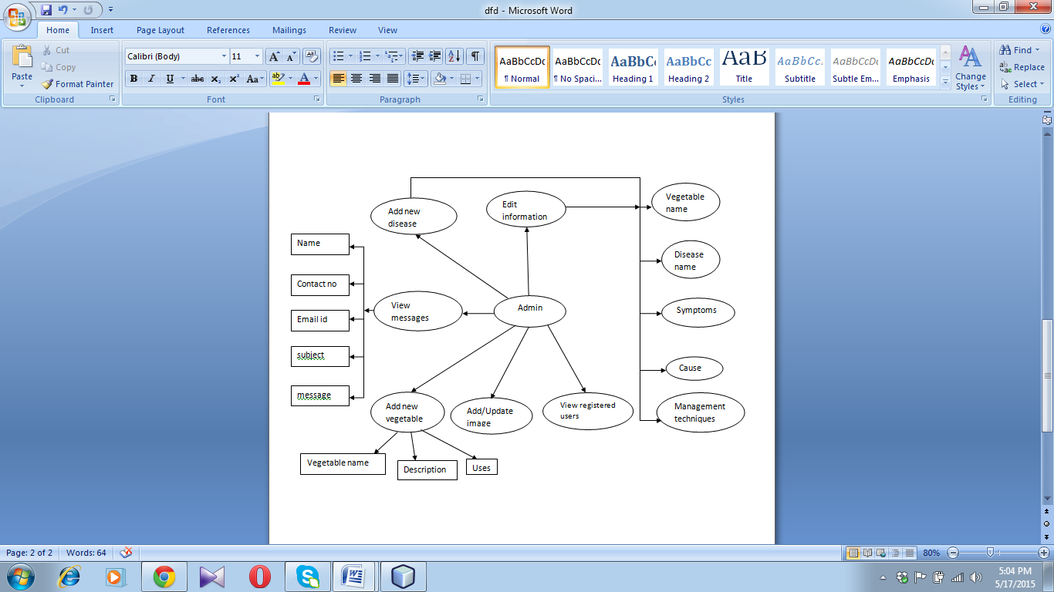

Figure :DFD for Administration

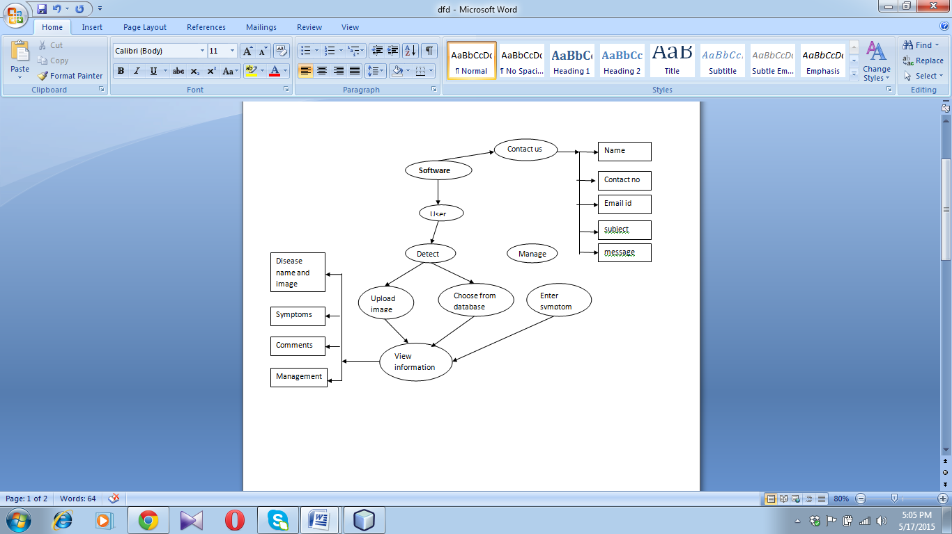

Figure :DFD for the User

1. **Results and Discussion**

It is difficult to identify the symptoms of the diseases by any non-expert person. They also don’t know which management techniques can be used once the vegetable is infected. Farmers are often dependent on the experts for the right information about the leafy vegetables diseases. This solution is time consuming. The proposed software has been designed and developed to provide the solution in an efficient way. The proposed software is web-based software that provides a user-friendly experience. The farmers can get the information about the diseases of the leafy vegetables and the necessary management techniques that can be used to prevent the diseases without depending on the experts.

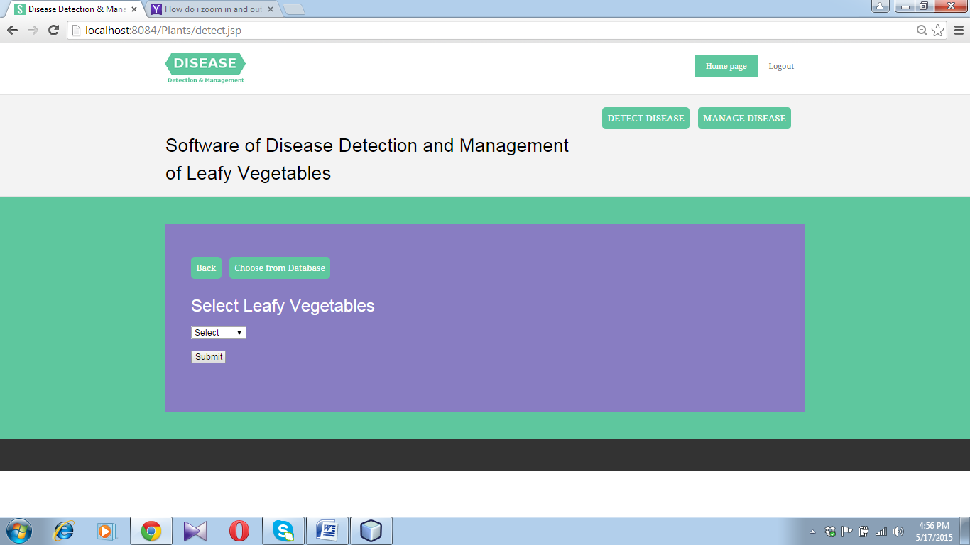

Figure : User screen for "Detect Disease"

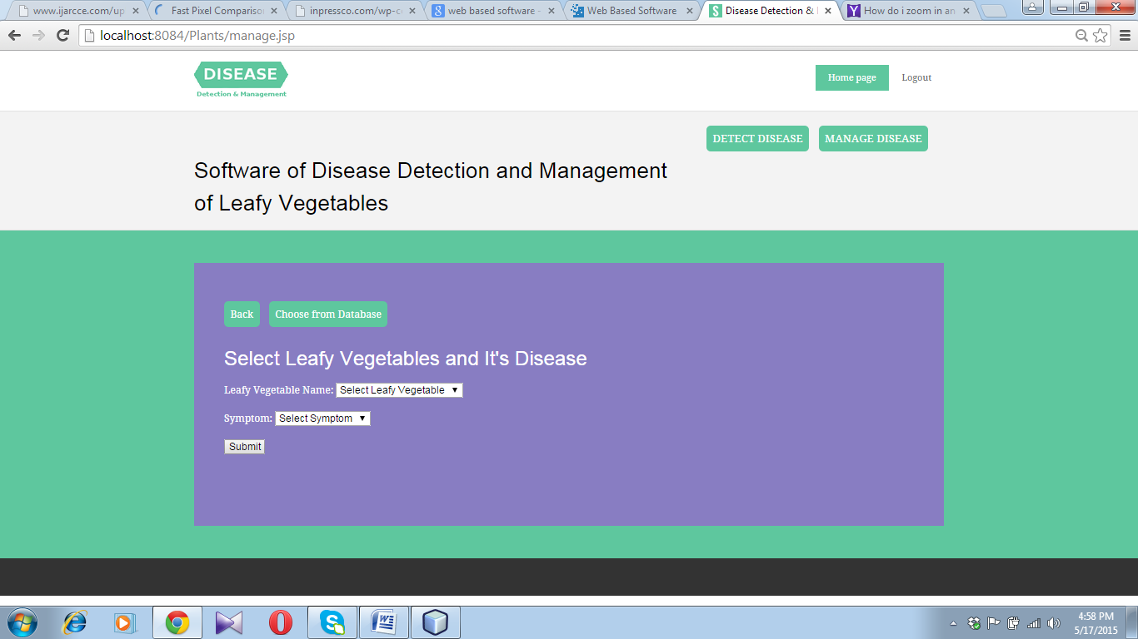

Figure : User screen for "Manage disease"

1. **Future scope**

Although the web technology is used in almost every part in the country, many farmers are illiterate in the rural areas. The proposed software can be expanded and developed in the regional languages. The software can be updated to accommodate new diseases of the leafy vegetables by adding more images. The software can also be made functional for other vegetable plants also. New vegetables, its diseases and images can be added to the software.

1. **References:**

Khan F S, Razzaq S, Irfan K, Maqbool F, Farid A, Illahi I and Amin T (2008) Dr Wheat: A web based

expert system for diagnosis of diseases and pests in Pakistani wheat. *Proc of the World Congr on*

*Engineering. Vol 1, London, U K.*

Krasula L, Klíma M,Rogard E and Jeanblanc E (2011) MATLAB-based Applications for

Image Processing and Image Quality Assessment – Part I: Software Description. *Dept of*

*Radioelectronics, Czech Technical Uni in Prague* **20**:1009-1015

Krishnan M, Jabert G (2013) Pest Control in Agricultural Plantations Using Image Processing. *IOSR*

*Journal of Electronics and Communication Engineering* **6**: 68-74

Kulkarni A, Patil A (2012) Applying image processing technique to detect plant diseases. *Int Journal of*

*Modern Engineering Research* **2**: 3661-3664

Lai J, Ming B, Li S, Wang K, Xie R and Gao J (2010) An Image based diagnostic expert system for corn

diseases.*Agri Sci in China* **9**(8):1221-1229

Mohammed T S, Al-Azzo W, and Mashani K M (2013) Image processing development and

implementation: a software simulation using matlab®. *The 6th ICIT*

Nandagopalan S, Adiga B S and Deepak N (2008) A Universal Model for Content-Based Image Retrieval*. World Academy of Science, Engineering and Technology* **2**:580-583

Patil J, Kumar R (2011) Advances in image processing for detection of plant diseases. *Journal of*

*Advanced Bioinformatics Applications and Research* **2**:135-141

Rathod A, Tanawal B and Shah V (2013) Image Processing Techniques for Detection of Leaf Disease. *Int*

*Journal of Advanced Research in Comp Science and Software Engg* **3:**397-399

Vibhute A, Bodhe S (2012) Applications of Image Processing in Agriculture: A Survey. *Int. Journal of*

*Computer Applications* **52**:34-40